Section A – Theory
- What is a SQL JOIN? Why do we use JOINs?
A SQL JOIN is used to combine rows from two or more tables based on a related column.
2. Difference between INNER JOIN, LEFT JOIN, RIGHT JOIN, and FULL OUTER JOIN
- INNER JOIN: Returns only the rows that have matching values in both tables. If a row in one table does not have a matching row in the other, it is excluded from the result.
- LEFT JOIN: Returns all rows from the left table, and the matched rows from the right table. If there is no match, the columns of the right table are filled with NULL.
- RIGHT JOIN: Returns all rows from the right table, and the matched rows from the left table. If there is no match, the columns of the left table are filled with NULL.
- FULL OUTER JOIN: Returns all rows when there is a match in either the left or right table. Missing matches on either side are populated with NULL.
3. What are Aggregate Functions?
Aggregate functions perform calculations on multiple rows and return a single value.
4. What is the purpose of GROUP BY?
The GROUP BY clause groups rows that have the same values into summary rows.
5. Difference between WHERE and HAVING
- WHERE: Filters individual rows before any groupings or aggregations take place. It cannot be used with aggregate functions.
- HAVING: Filters group summaries after the GROUP BY clause has been evaluated. It is specifically designed to filter records based on aggregate function conditions.
6. Subqueries and Real-World Use Case
- A Subquery (or nested query) is an SQL query embedded inside another SQL query's WHERE, FROM, HAVING, or SELECT clause.
- Real-world use case: Identifying fraud or outliers, such as generating a list of users whose transaction amounts are higher than the average daily transaction value of the entire system.
7. Purpose of ORDER BY
- The ORDER BY clause sorts the result set of a query in either ascending (ASC, default) or descending (DESC) order based on one or more columns.

Section B – SQL Queries

1. Display all employees along with their department names.
SELECT e.EmpId, e.Name, e.Salary, d.DepartmentName
FROM Employee e
INNER JOIN Department d ON e.DepartmentId = d.DepartmentId;
2.Display employees from the *IT* department.
SELECT d.DepartmentId, d.DepartmentName, e.Name
FROM Department d
LEFT JOIN Employee e ON d.DepartmentId = e.DepartmentId;
3. Total salary paid for each department
SELECT d.DepartmentName, SUM(e.Salary) AS TotalSalary
FROM Department d
INNER JOIN Employee e ON d.DepartmentId = e.DepartmentId
GROUP BY d.DepartmentName;
4. Average salary of employees in each department
SELECT d.DepartmentName, AVG(e.Salary) AS AverageSalary
FROM Department d
INNER JOIN Employee e ON d.DepartmentId = e.DepartmentId
GROUP BY d.DepartmentName;
5. Highest salary in each department
SELECT d.DepartmentName, MAX(e.Salary) AS HighestSalary
FROM Department d
INNER JOIN Employee e ON d.DepartmentId = e.DepartmentId
GROUP BY d.DepartmentName;
6. Departments where the average salary is greater than 55,000
SELECT d.DepartmentName, AVG(e.Salary) AS AverageSalary
FROM Department d
INNER JOIN Employee e ON d.DepartmentId = e.DepartmentId
GROUP BY d.DepartmentName
HAVING AVG(e.Salary) > 55000;
7. Count the number of employees in each department
SELECT d.DepartmentName, COUNT(e.EmpId) AS EmployeeCount
FROM Department d
LEFT JOIN Employee e ON d.DepartmentId = e.DepartmentId
GROUP BY d.DepartmentName;
8. Employees whose salary is greater than the average salary of all employees
SELECT EmpId, Name, Salary
FROM Employee
WHERE Salary > (SELECT AVG(Salary) FROM Employee);
9. Top 3 highest-paid employees
SELECT Name, Salary
FROM Employee
ORDER BY Salary DESC
LIMIT 3;
10. Department names in alphabetical order
SELECT DepartmentName
FROM Department
ORDER BY DepartmentName ASC;

Section C – Hands-on Practice
Perform the following tasks:

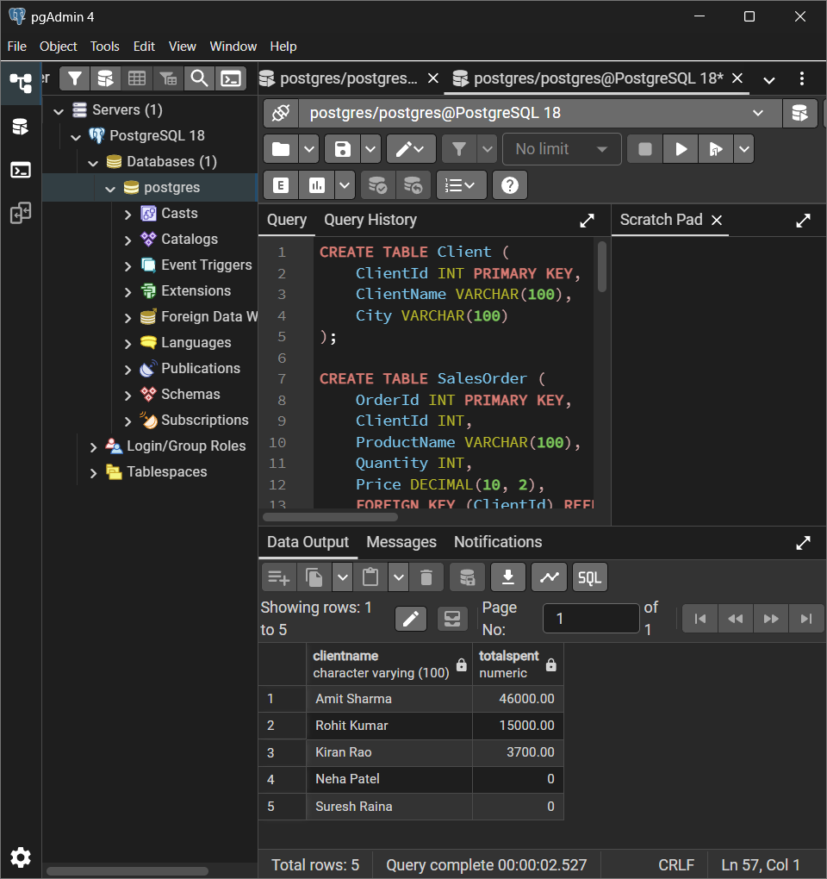
SQL QUERIES:
CREATE TABLE Client (
ClientId INT PRIMARY KEY,
ClientName VARCHAR(100),
City VARCHAR(100)
);

CREATE TABLE SalesOrder (
OrderId INT PRIMARY KEY,
ClientId INT,
ProductName VARCHAR(100),
Quantity INT,
Price DECIMAL(10, 2),
FOREIGN KEY (ClientId) REFERENCES Client(ClientId)
);

INSERT INTO Client (ClientId, ClientName, City) VALUES
(1, 'Amit Sharma', 'Delhi'),
(2, 'Rohit Kumar', 'Mumbai'),
(3, 'Neha Patel', 'Ahmedabad'),
(4, 'Kiran Rao', 'Bangalore'),
(5, 'Suresh Raina', 'Chennai');

INSERT INTO SalesOrder (OrderId, ClientId, ProductName, Quantity, Price) VALUES
(501, 1, 'Laptop', 1, 45000.00),
(502, 1, 'Mouse', 2, 500.00),
(503, 2, 'Smartphone', 1, 15000.00),
(504, 4, 'Headphones', 1, 2500.00),
(505, 4, 'Keyboard', 1, 1200.00);

SELECT c.ClientName, o.OrderId, o.ProductName, o.Quantity, o.Price
FROM Client c
INNER JOIN SalesOrder o ON c.ClientId = o.ClientId;
SELECT c.ClientName
FROM Client c
LEFT JOIN SalesOrder o ON c.ClientId = o.ClientId
WHERE o.OrderId IS NULL;
SELECT c.ClientName, COALESCE(SUM(o.Quantity * o.Price), 0) AS TotalSpent
FROM Client c
LEFT JOIN SalesOrder o ON c.ClientId = o.ClientId
GROUP BY c.ClientId, c.ClientName;
SELECT c.ClientName, SUM(o.Quantity * o.Price) AS TotalSpent
FROM Client c
INNER JOIN SalesOrder o ON c.ClientId = o.ClientId
GROUP BY c.ClientId, c.ClientName
HAVING SUM(o.Quantity * o.Price) > 10000;
SELECT c.ClientName, COUNT(o.OrderId) AS OrderCount
FROM Client c
INNER JOIN SalesOrder o ON c.ClientId = o.ClientId
GROUP BY c.ClientId, c.ClientName
ORDER BY OrderCount DESC
LIMIT 1;
SELECT c.ClientName, COALESCE(SUM(o.Quantity * o.Price), 0) AS TotalSpent
FROM Client c
LEFT JOIN SalesOrder o ON c.ClientId = o.ClientId
GROUP BY c.ClientId, c.ClientName
ORDER BY TotalSpent DESC;

Section D – Mini SQL Challenge
Complete the following challenges:

### Challenge 1
Find the department with the *highest average salary*.
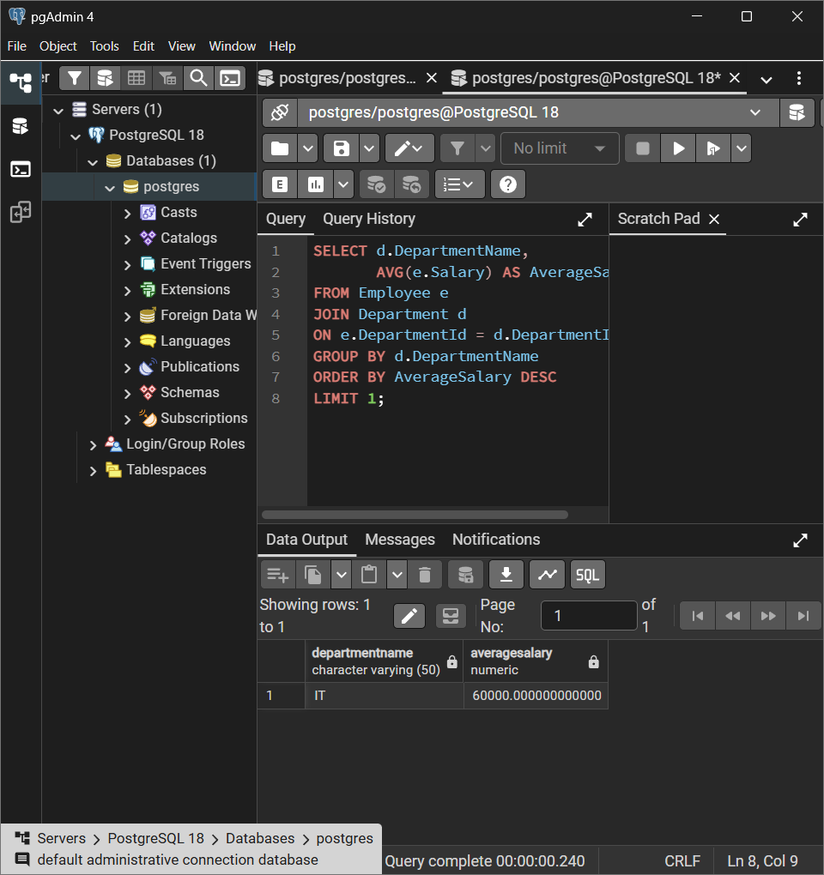
SELECT d.DepartmentName,
AVG(e.Salary) AS AverageSalary
FROM Employee e
JOIN Department d
ON e.DepartmentId = d.DepartmentId
GROUP BY d.DepartmentName
ORDER BY AverageSalary DESC
LIMIT 1;

### Challenge 2
Find employees earning more than the average salary of their own department.
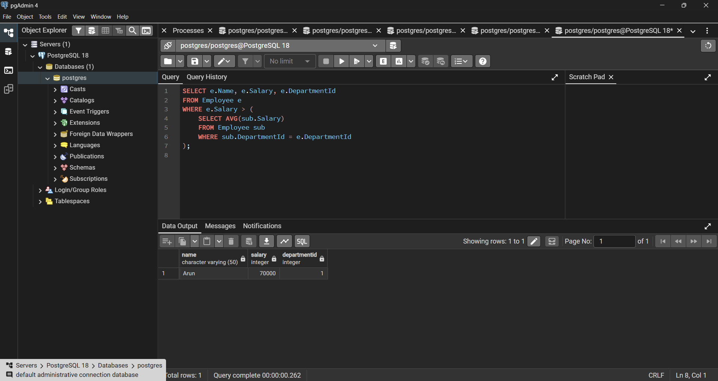

SELECT e.Name, e.Salary, e.DepartmentId
FROM Employee e
WHERE e.Salary > (
SELECT AVG(sub.Salary)
FROM Employee sub
WHERE sub.DepartmentId = e.DepartmentId
);
### Challenge 3
Display the *top 2 departments* with the highest total salary expenditure.
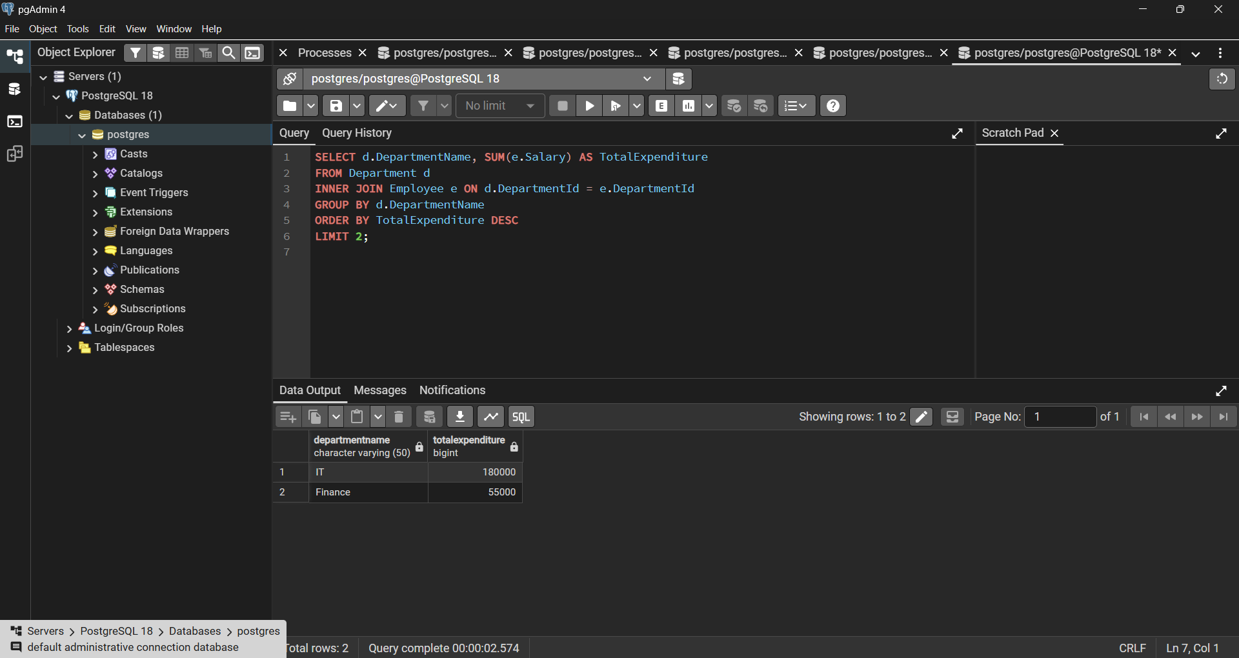
SELECT d.DepartmentName, SUM(e.Salary) AS TotalExpenditure
FROM Department d
INNER JOIN Employee e ON d.DepartmentId = e.DepartmentId
GROUP BY d.DepartmentName
ORDER BY TotalExpenditure DESC
LIMIT 2;
### Challenge 4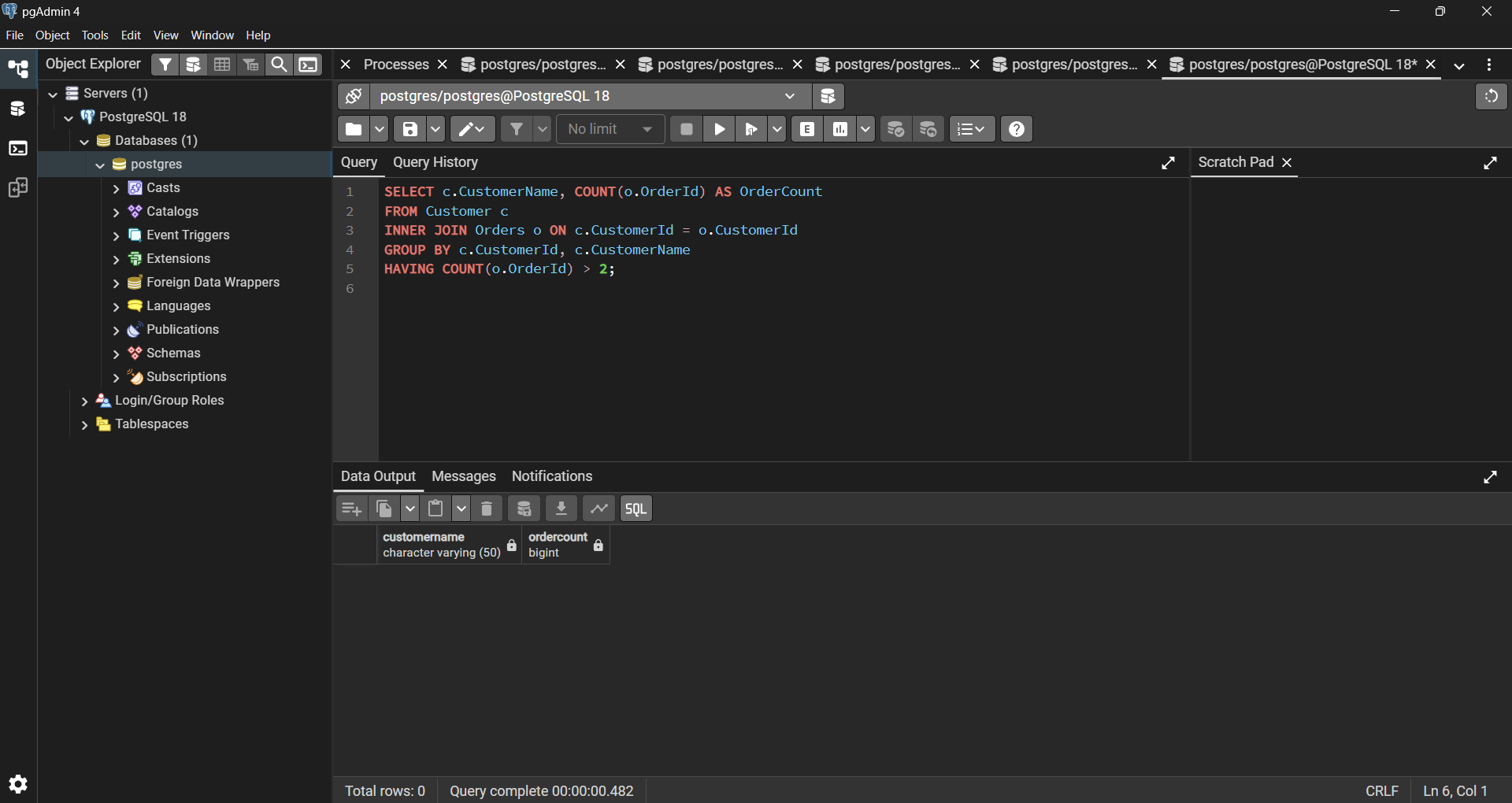
Find customers who have placed *more than two orders*.

SELECT c.CustomerName, COUNT(o.OrderId) AS OrderCount
FROM Customer c
INNER JOIN Orders o ON c.CustomerId = o.CustomerId
GROUP BY c.CustomerId, c.CustomerName
HAVING COUNT(o.OrderId) > 2;
### Challenge 5
Write a query to display the *second highest salary* from the Employee table.
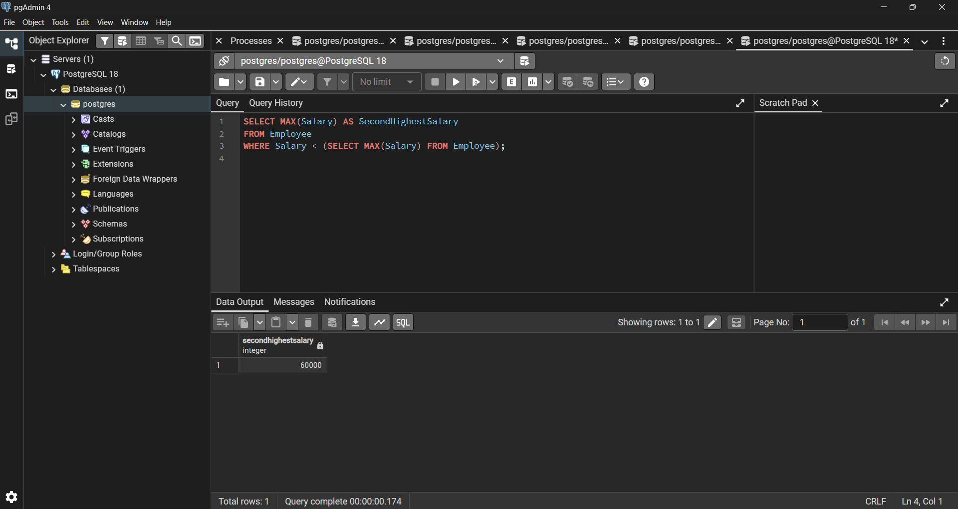

SELECT MAX(Salary) AS SecondHighestSalary
FROM Employee
WHERE Salary < (SELECT MAX(Salary) FROM Employee);

